Sylvia Hammarstrom, Owner SKANSEN KENNEL
P.O. Box 400
Sebastopol, CA 95473
Business: 707-795-7070
info@skansen.com

BLACK STANDARD SCHNAUZERS PUP FOR SALE
MAY 31, 2017

- MALE, CROPPED, PET, BY MICROCHIP AND WOODY, BORN APRIL 16, 2017 – CROPPED EARS $2200, UNCROPPED EARS $1500.

- ONE FEMALE, UNCROPPED, PET, BY MARTHA AND DANTE, BORN MARCH 10,
2017 - $1500.

- MALE AND FEMALE BY MONACO AND KINGPIN BORN MAY 26, 2017

WE KEEP OUR PUPS UNTIL 10-12 WEEKS OLD IF EARS ARE UNCROPPED ($1500 + SHIPPING). IF YOU LIKE EARS CROPPED, WE KEEP THEM UNTIL 16 WEEKS OLD ($2200 + SHIPPING). SHOW PUP IS $2000 UNCROPPED OR $2700 WITH CROPPED EARS.
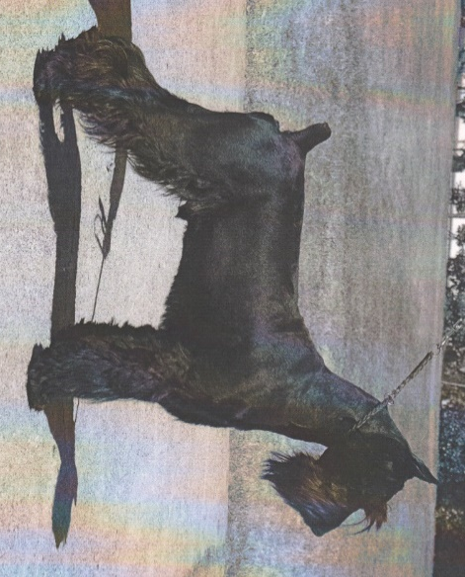
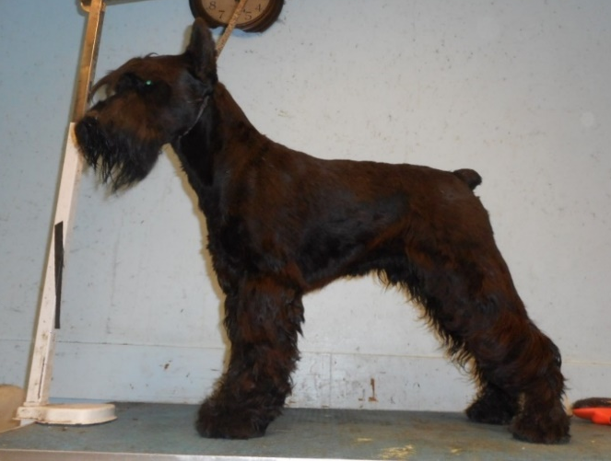

FOREIGN AFFAIR DANTE SKANSEN’S KINGPIN

